Digital Portfolio

The digital portfolio’s purpose is an opportunity to tell a future I.T employer about myself and my skills that I have in different technology areas. It is a reflection of my personal and professional journey and future goals. It will show what I have done at college with my experience in welding, motor mechanics, vehicle paint and body, engineering and information technology. This digital portfolio will display visual elements such as photographs of my work to visually show an employer my skills and will mean that it is more engaging. It will also tell them information about me, my fields of interests, qualifications, courses taken and are presently completing and my interests and any work experience that I have accrued. My contact details are included. This portfolio is a well designed, strong and professional showcase and is designed to give me the best possible chance of employment with it’s content and eye catching layout. It is easy to navigate, clear providing concise descriptions of each project, any technologies used and the outcomes achieved. It will also be visually appealing. Most importantly it also directly shows a prospective employer my skills using web creation software (HTML/CSS) and will be accessible via a public URL.

It is worth mentioning that there are disadvantages of online portfolios. This can include potential issues regarding privacy and the exposure of private information and work details. Publicly showcasing work and information can also lead to unwanted criticism and attention.

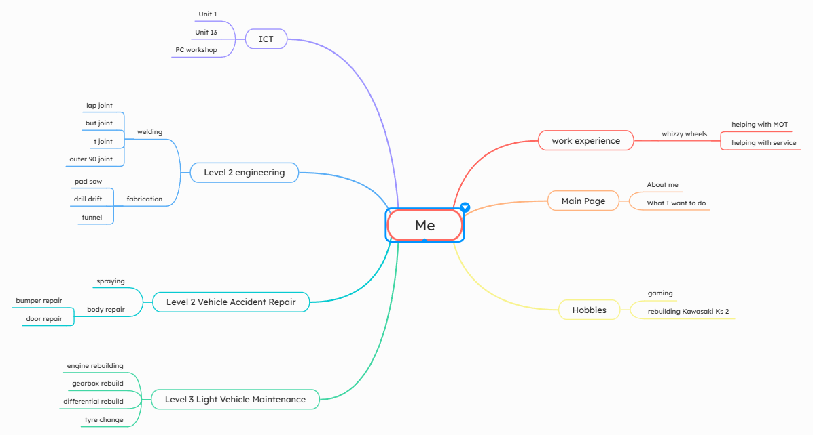

Alternate designs

The photo boxes are place holders that will have photos of the relevant topic on the actual portfolios

The text boxes are place holders that will not be visible on the actual portfolio and will hold text

The nav bar colour will be #94E6FF

The footer colour will be #6493BD

The banner colour will be #1082E6

The background colour will be #DAE8FC

This is the nav bar for the portfolio and how the pages will be linked

Picture of me and my interest

Picture of vehicle maintenance

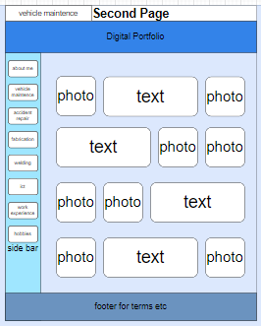

Text about myself

Text about vehicle maintenance

Picture of accident repair

Picture of fabrication

Text about fabrication

Text about accident repair

Picture of lvl2 ICT

Picture of welding

Text about welding

Text about lvl2 ICT

Picture of work experience

Picture of my hobbies

Text about vehicle maintenance

Text about vehicle maintenance

This Is the timeline of the whole project

|  |  |  |
| --- | --- | --- |
| assets | description | source |
|  | Project bike that I started restoring | C:\Users\421453\OneDrive - The College of West Anglia\ICT\Unit 03\assets |
|  | Working on internal components | C:\Users\421453\OneDrive - The College of West Anglia\ICT\Unit 03\assets |
|  | Checking engine block level | C:\Users\421453\OneDrive - The College of West Anglia\ICT\Unit 03\assets |
|  | Picture of finished sprayed part | C:\Users\421453\OneDrive - The College of West Anglia\ICT\Unit 03\assets |
|  | Picture of my motorbike | C:\Users\421453\OneDrive - The College of West Anglia\ICT\Unit 03\assets |
|  | Picture of dream car | C:\Users\421453\OneDrive - The College of West Anglia\ICT\Unit 03\assets |
|  | Picture of first attempt at welding | C:\Users\421453\OneDrive - The College of West Anglia\ICT\Unit 03\assets |
|  | Picture of project bike frame damage | C:\Users\421453\OneDrive - The College of West Anglia\ICT\Unit 03\assets |
|  | Picture of group project car from accident repair | C:\Users\421453\OneDrive - The College of West Anglia\ICT\Unit 03\assets |

This is the structure chart of the portfolio showing the navigation routes

This is what the file names of the pages that will be made will be called

1. Home = Index.html
2. Vehicle maintenance = Maintenance.html
3. Accident repair = Repair.html
4. Fabrication = Fab.html
5. Welding = Weld.html
6. Level 2 ICT = ICT.html
7. Work experience = Work.html
8. Hobbies = Hobby.html

Justification of the final designs:

I have designed my digital portfolio so that it meets the need of the future IT employers. I have used my IT website design skills, using HTML code, CSS and my own images. I have chosen to show employers not just my IT skills but also how I can repair a car and bike when I need to, using the images The design is simple, strong and professional and is designed to give me the best possible chance of employment with its content and eye catching layout. I laid out my portfolio the way I did because it is easy to use and easy to navigate because of the navigation bar at the side. There are eight pages linked within the navigation bar, them being about me, vehicle maintenance, accident repair, fabrication, welding, ICT, work experience and hobby pages. Each page will have clear headings and a short introduction about what on the page. The reason I chose this specific design that I did was to avoid a large amount of text on the portfolio, I want the employer to quickly see my skills and qualifications visually instead of talk about them. When it comes to colours, I have chosen blue to keep the employer engaged. Blue has psychological appeal and is associated with trust, calmness and reliability. This is very relevant in regard to appealing to prospective employers. I have screenshots of my IT projects as well to talk about.

The assets enhance the user experience because they show what I have done on the courses, my practical skills and evidence of tools, showing how to correctly use them. For example, in the hobbies page there will be an image that shows me using a vernier calliper to measure the intake port size to get the correct size carburettor, I will add a short description of what the image is under the images. On the different pages I am going to put images that align with the page focus i.e. the vehicle maintenance page will have a picture of me removing spark plugs from the engine using a socket and rachet with an extension bar. On the accident repair page, I will put a before and after picture of a car that we spray painted as a group. The about me pages will have a picture of me and my most interesting things about me on it. The welding page will have pictures of what I managed to achieve with MIG welding. The fabrication page will have pictures of what I made on the course.

I chose the first design over the alternative because it is more professional with it being more organised than the alternative design and keeps the employer engaged. Each page is clearly labelled and demonstrates my skills better which improves the overall user experience.